ITA0305- Mobile Computing
LAB EXPERIMENT
Name: G.Ganesh
Reg NO:192373008

9) Develop a user interface prototype for a GSM service using Figma.
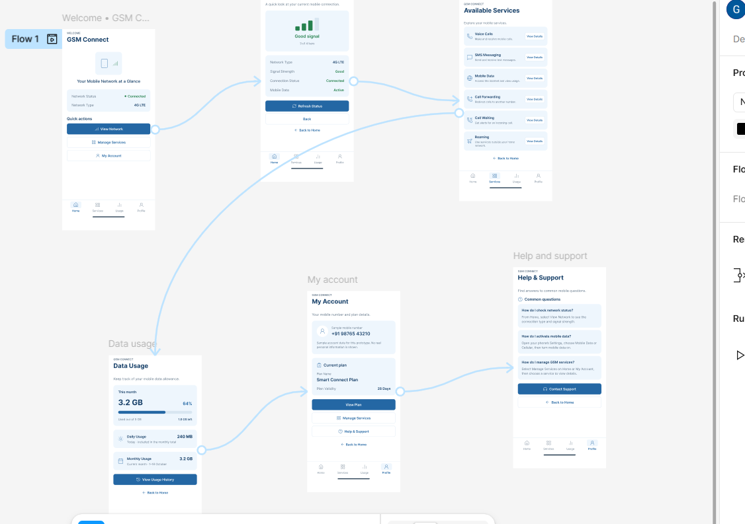
https://www.figma.com/design/RWoQAiZeAYgkDlQj3Erkdu/program09?node-id=0-1&p=f&t=7V8NXOJ1ecOAWj2u-0

